LAB 2
INSTALLING AND CONFIGURING BIND9 FOR DVWA DOMAIN NAME RESOLUTION ON KALI LINUX

Student ID: 24560025
Student Name: Dao Minh Chau

Objective
Students will learn to:
Install and configure BIND9 as a private DNS server on Kali Linux.
Set up DNS resolution for the DVWA website to allow access via a domain name .
Configure forward and reverse DNS zones to map domain name to the web server’s IP .
Test and verify DNS resolution for client access to DVWA.

Network Configuration
Web Server & DNS Server: 192.168.241.131 (hosts DVWA and BIND9).
Database Server: 192.168.241.132.
Domain Name: dvwa.local (resolves to 192.168.241.131).
Client Network: 192.168.241.135 (clients query the DNS server and access DVWA).
Note: Explanation is highlighted in yellow.

Part 1: Web Server Setup (VM1: 192.168.241.131)
Step 1: Update the System
Command:
sudo apt update && sudo apt upgrade -y: update and upgrade kali to the newest files
Function: Ensures VM1 is up-to-date with the latest security patches and package versions, preventing compatibility issues during LAMP stack installation.

Step 2: Install Apache, PHP, and Dependencies
Command:
sudo apt install apache2 php php-mysql php-gd git -y

where:
apache2: Apache web server to host DVWA.
php: PHP interpreter for DVWA’s dynamic content.
php-mysql: PHP extension for database connectivity.
php-gd: PHP extension for image processing (used by DVWA for CAPTCHAs).
git: Tool to clone the DVWA repository.
-y: Confirms installation prompts.
Note: MariaDB is not installed on VM1, as the database server is on VM2 (192.168.241.132).
Function: Sets up the web server environment on VM1 to host DVWA, excluding the database component.

Step 3: Enable and Start Apache
Commands:
sudo systemctl enable apache2
sudo systemctl start apache2
sudo systemctl status apache2

Explanation:
sudo systemctl enable apache2: Configures Apache to start automatically on system boot.
sudo systemctl start apache2: Starts the Apache service immediately.
sudo systemctl status apache2: Verifies Apache is running (Active: active (running)).
Function: Activates the Apache web server on VM1 and ensures it persists across reboots, allowing DVWA to be served.
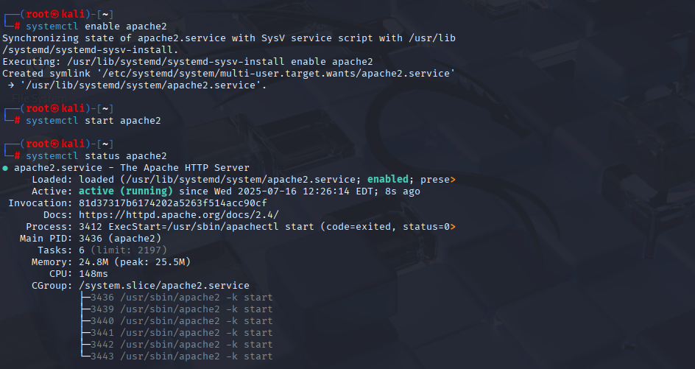

Step 4: Clone the DVWA Repository
Commands:
cd /var/www/html: change directory to Apache’s default web root directory.
sudo git clone https://github.com/digininja/DVWA.git: Downloads the DVWA source code from GitHub into /var/www/html/DVWA.

sudo chown -R www-data:www-data /var/www/html/DVWA: set ownership to the www-data user and group
sudo chmod -R 755 /var/www/html/DVWA: Grants the owner full access (read, write, execute) and others read/execute access for security and functionality.

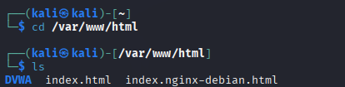

Step 5: Configure PHP
Commands:
sudo nano /etc/php/*/apache2/php.ini
Set:
allow_url_include = On: Enables PHP to include files from URLs, required for DVWA’s file inclusion vulnerabilities.
Then:
sudo systemctl restart apache2: restart the apache2 to update the configuration.

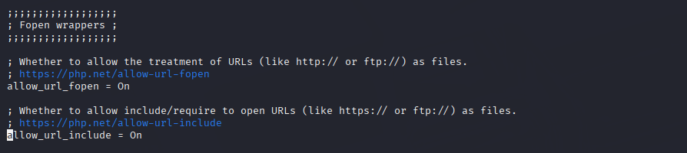
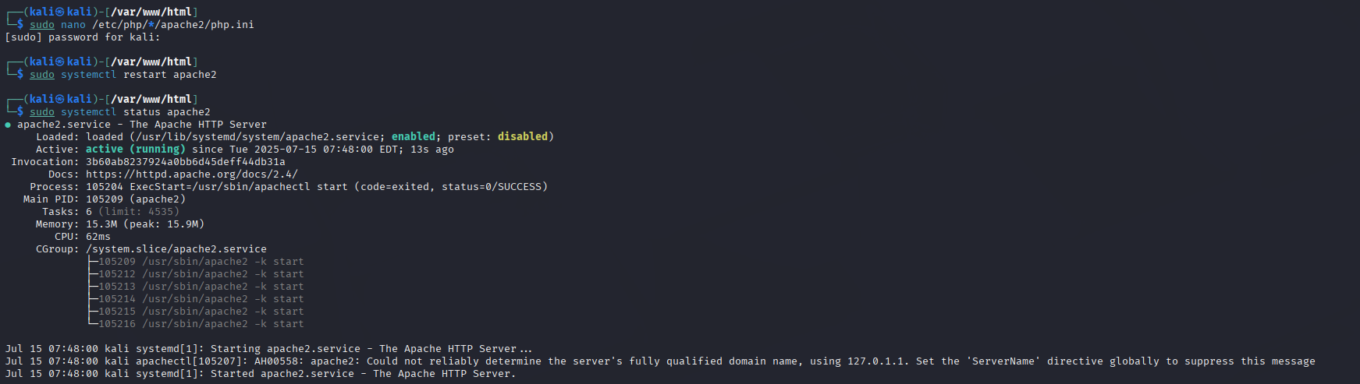

Part 2: Database Server Setup (VM2: 192.168.241.132)
Step 6: Update the System
Command:
sudo apt update && sudo apt install mariadb-server -y

Explanation:
sudo apt update: Refreshes the package index on VM2.
sudo apt install mariadb-server -y: Installs MariaDB, the database server, on VM2.
-y: Confirms installation prompts.
Function: Ensures VM2 has the latest package information and installs MariaDB to store DVWA’s data.

Step 7: Enable and Start MariaDB
Commands:
sudo systemctl enable mariadb: activate the database
sudo systemctl start mariadb: start the database
sudo systemctl status mariadb: check database status.

Function: Activates the MariaDB service on VM2, ensuring the database server is operational.
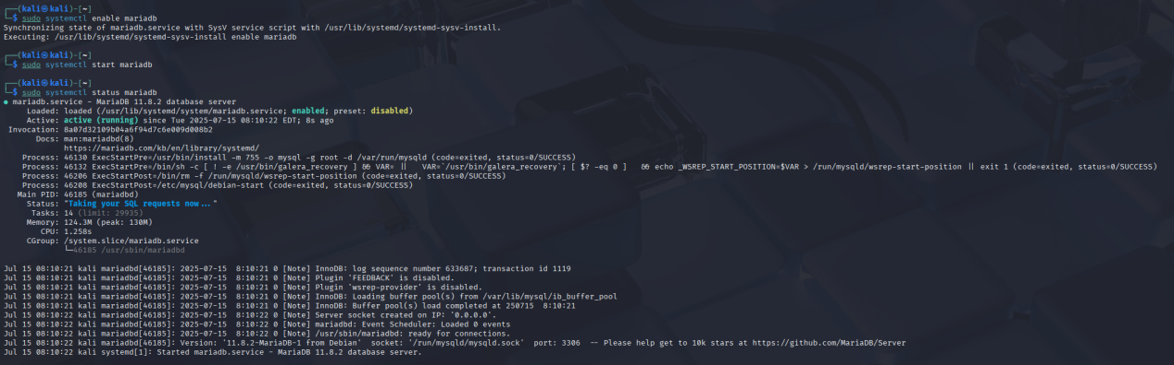

Step 8: Configure the DVWA Database
Commands:
sudo mariadb
Execute:
DROP DATABASE IF EXISTS dvwa;: delete any existed database named dvwa
CREATE DATABASE dvwa;: create a new database
CREATE USER 'dvwa'@'192.168.241.131' IDENTIFIED BY 'dvwa';: create a user identified by database dvwa
GRANT ALL PRIVILEGES ON dvwa.* TO 'dvwa'@'192.168.241.131';: set permission to the user
FLUSH PRIVILEGES;
EXIT;
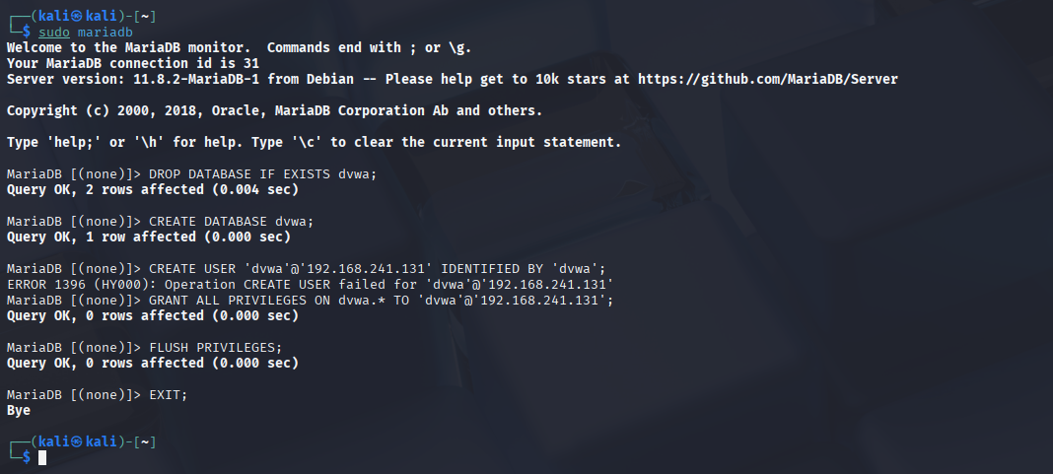

Step 9: Allow Remote Database Connections
Commands:
sudo nano /etc/mysql/mariadb.conf.d/50-server.cnf : edit the file
Set:
bind-address = 0.0.0.0: Allows MariaDB to accept connections from any IP, enabling VM1 (192.168.241.131) to connect.
Then:
sudo systemctl restart mariadb: Restarts MariaDB to apply the configuration.
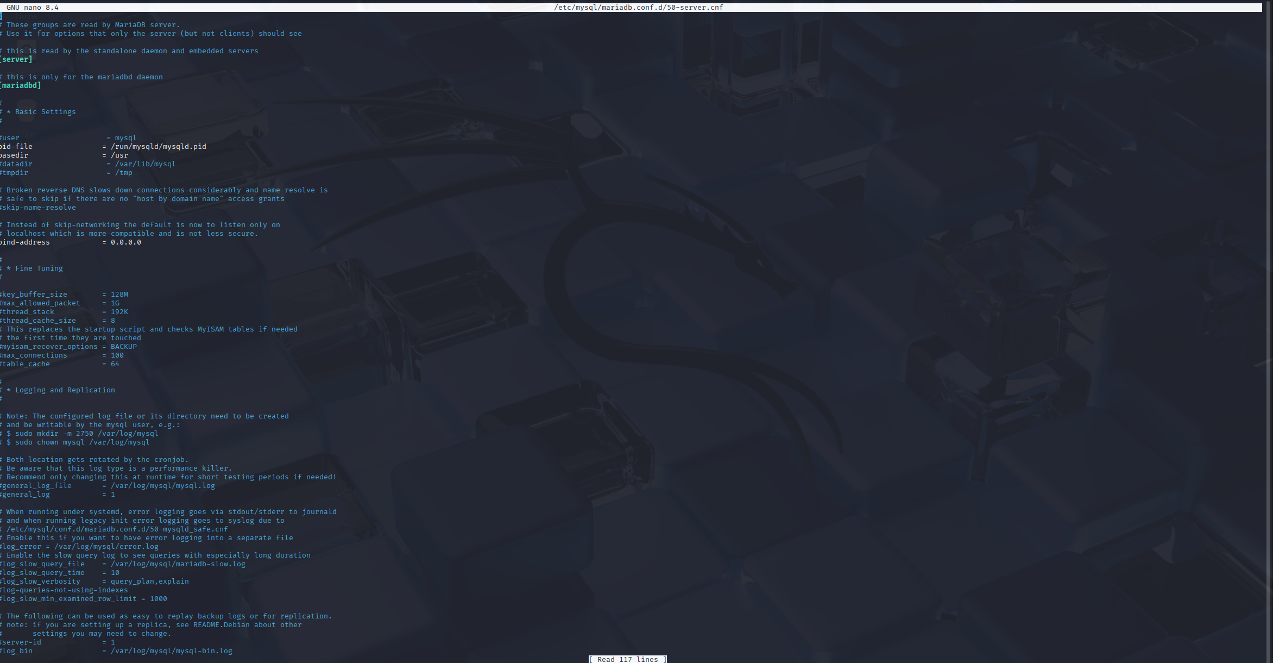
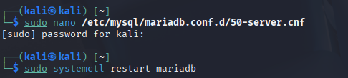

Part 3: Configure DVWA (VM1: 192.168.241.131)
Step 10: Configure DVWA
Commands:
cd /var/www/html/DVWA/config: Navigates to the DVWA configuration directory on VM1.

sudo cp config.inc.php.dist config.inc.php: copy the default configuration file to a working file
sudo nano config.inc.php: edit the file
Set:
$_DVWA['db_server'] = '192.168.241.132';: set DVWA to the database server on VM2
$_DVWA['db_user'] = 'dvwa';: set the database user
$_DVWA['db_password'] = 'dvwa';:Set the user’s password
$_DVWA['db_database'] = 'dvwa';: names the database

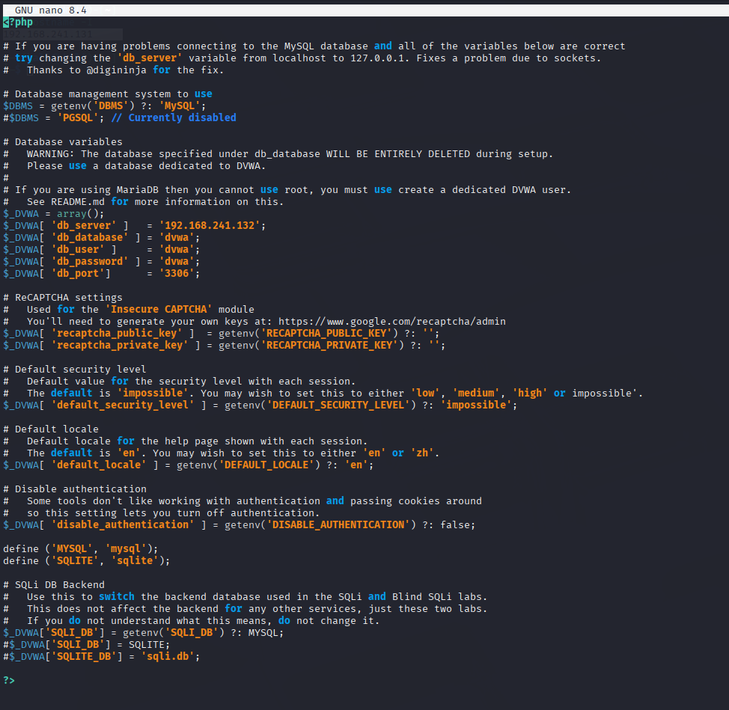

Part 4: DNS Server Setup (VM1: 192.168.241.131)
Step 11: Install BIND9 and Required Tools
Command:
sudo apt update && sudo apt install bind9 bind9utils dnsutils -y

The command above installs:
bind9: DNS server software.
bind9utils: Tools for managing BIND9 (e.g., rndc).
dnsutils: Utilities like dig and nslookup for testing.
Function: Installs BIND9 and tools on VM1 to enable DNS resolution for dvwa.local.
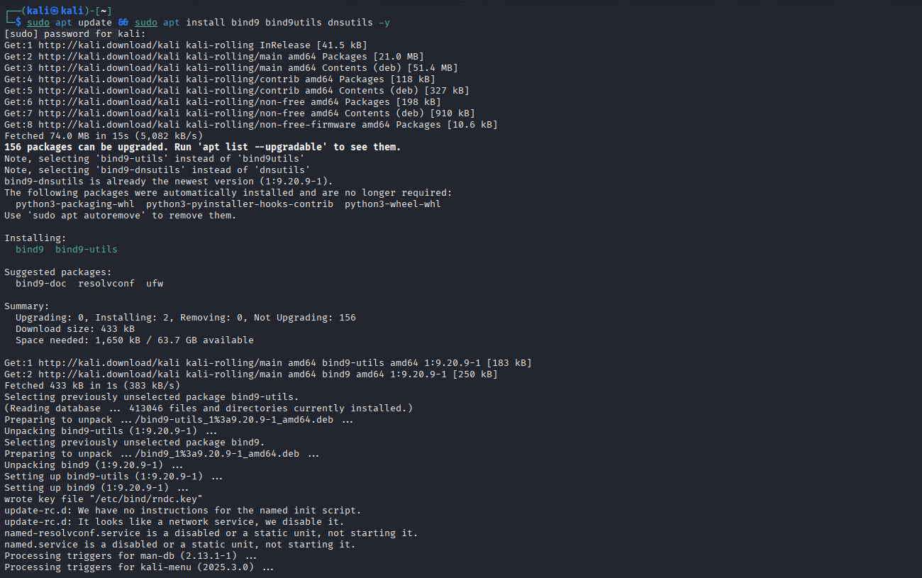

Step 12: Configure BIND9 Options
Commands:
sudo nano /etc/bind/named.conf.options: edit the file
Add or modify:
acl trusted {
192.168.241.0/24; // Allow queries from this network
localhost;
};
options {
directory "/var/cache/bind";
allow-query { trusted; };
forwarders {
8.8.8.8;
8.8.4.4;
};
recursion yes;
dnssec-validation auto;
listen-on-v6 { none; }; // Disable IPv6 for simplicity
};

acl trusted: Allows DNS queries from the 192.168.241.0/24 LAN and localhost.
directory "/var/cache/bind": Sets the directory for cache and zone files.
allow-query { trusted; }: Restricts queries to the trusted ACL.
forwarders { 8.8.8.8; 8.8.4.4; }: Uses Google’s DNS for external queries.
recursion yes: Enables recursive queries.
dnssec-validation auto: Enables DNSSEC validation.
listen-on-v6 { none; }: Disables IPv6 to match the LAN’s IPv4 setup.
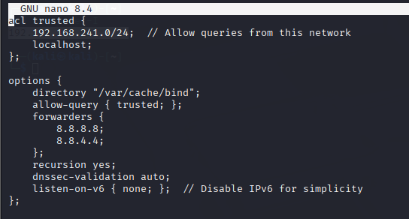

Step 13: Define DNS Zones
Commands:
sudo nano /etc/bind/named.conf.local: edit the file
Add:
zone "dvwa.local" {
type master;
file "/etc/bind/zones/db.dvwa.local";
};
zone "241.168.192.in-addr.arpa" {
type master;
file "/etc/bind/zones/db.192.168.241";
};

The content of the file allows reversed lookup so when user enter the ip address, it automatically trace to the domain name.
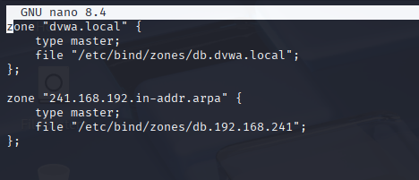

Step 14: Create Zone Files Directory
Commands:
sudo mkdir -p /etc/bind/zones: Creates a directory for zone files on VM1.
sudo chown bind:bind /etc/bind/zones: Sets ownership to the bind user and group.
sudo chmod 755 /etc/bind/zones: Grants full access to bind and read/execute to others.

Step 15: Create Forward Zone File
Commands:
sudo nano /etc/bind/zones/db.dvwa.local
Add:
$TTL 604800
@ IN SOA ns1.dvwa.local. admin.dvwa.local. (
2025071401 ; Serial
3600 ; Refresh
1800 ; Retry
604800 ; Expire
86400 ) ; Negative Cache TTL
;
@ IN NS ns1.dvwa.local.
ns1 IN A 192.168.241.131
dvwa.local. IN A 192.168.241.131
www IN CNAME dvwa.local.

sudo nano /etc/bind/zones/db.dvwa.local: Creates the forward zone file on VM1.
$TTL 604800: Sets the Time-To-Live (7 days).
SOA: Defines the nameserver (ns1.dvwa.local) and admin email (admin.dvwa.local).
NS: Specifies ns1.dvwa.local as the nameserver.
A: Maps ns1.dvwa.local and dvwa.local to 192.168.241.131.
CNAME: Aliases www.dvwa.local to dvwa.local.
Function: Configures DNS to resolve dvwa.local and www.dvwa.local to VM1’s IP.
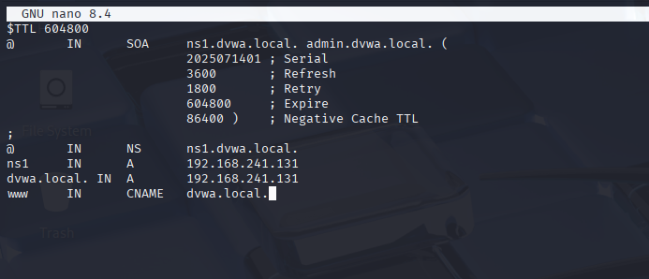

Step 16: Create Reverse Zone File
Commands:
sudo nano /etc/bind/zones/db.192.168.241
Add:
$TTL 604800
@ IN SOA ns1.dvwa.local. admin.dvwa.local. (
2025071401 ; Serial
3600 ; Refresh
1800 ; Retry
604800 ; Expire
86400 ) ; Negative Cache TTL
;
@ IN NS ns1.dvwa.local.
131 IN PTR dvwa.local.

sudo nano /etc/bind/zones/db.192.168.241: Creates the reverse zone file on VM1.
$TTL 604800: Sets the TTL.
SOA: Defines authoritative information.
NS: Specifies the nameserver.
PTR: Maps 192.168.241.131 to dvwa.local.
Function: Enables reverse DNS resolution for 192.168.241.131.
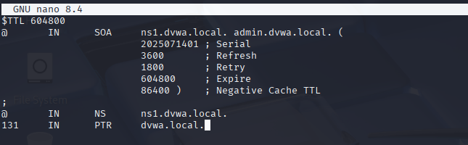

Step 17: Verify BIND9 Configuration
Commands:
sudo named-checkconf: Checks BIND9 configuration file syntax on VM1.
sudo named-checkzone dvwa.local ...: Verifies the forward zone file.
sudo named-checkzone 241.168.192.in-addr.arpa ...: Verifies the reverse zone file.

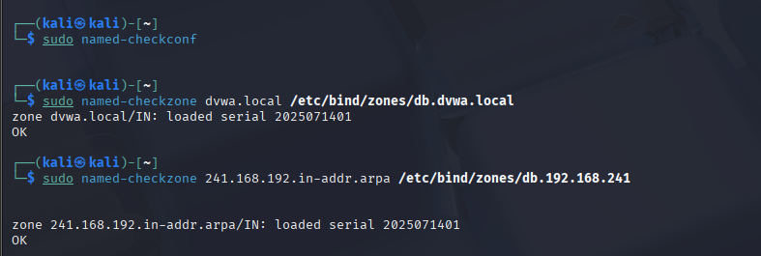

Step 18: Start and Enable BIND9
Commands:
sudo systemctl start bind9: Starts BIND9 on VM1.
sudo systemctl enable bind9: Configures BIND9 to start on boot.
sudo systemctl status bind9: Confirms BIND9 is running.
*NOTE: In some old versions of kali the name of bind9.service will be registered as named.service like mine.
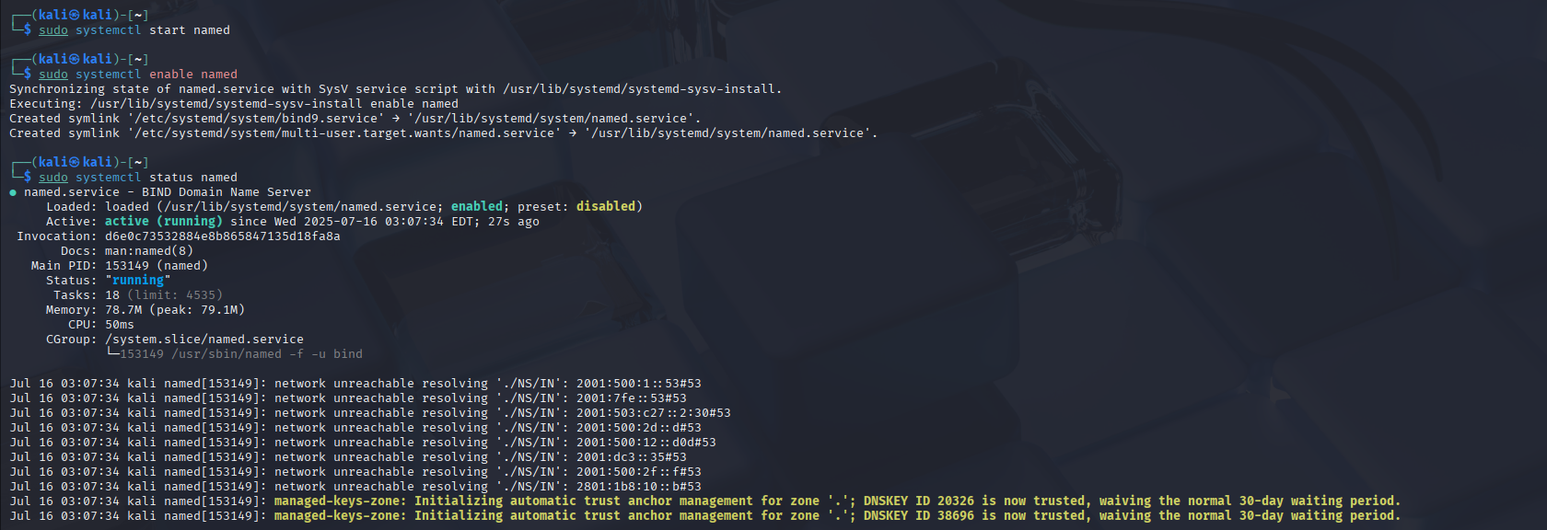

Part 5: Verify Setup
Step 19: Verify Web and Database Setup
Commands:
On VM1, open a browser or use curl:
curl http://192.168.241.131/DVWA/setup.php
Access in a browser:
http://192.168.241.131/DVWA/setup.php
Click Create / Reset Database.
Log in at:
http://192.168.241.131/DVWA/login.php
Use:
Username: admin
Password: password

Explanation:
curl http://192.168.241.131/DVWA/setup.php: Tests web server access on VM1.
Accessing setup.php: Loads DVWA’s setup page, which connects to VM2’s database.
Clicking Create / Reset Database: Initializes database tables on VM2.
Logging in: Verifies DVWA functionality with default credentials.
Function: Confirms that the web server (VM1) and database server (VM2) are correctly configured and DVWA is operational.
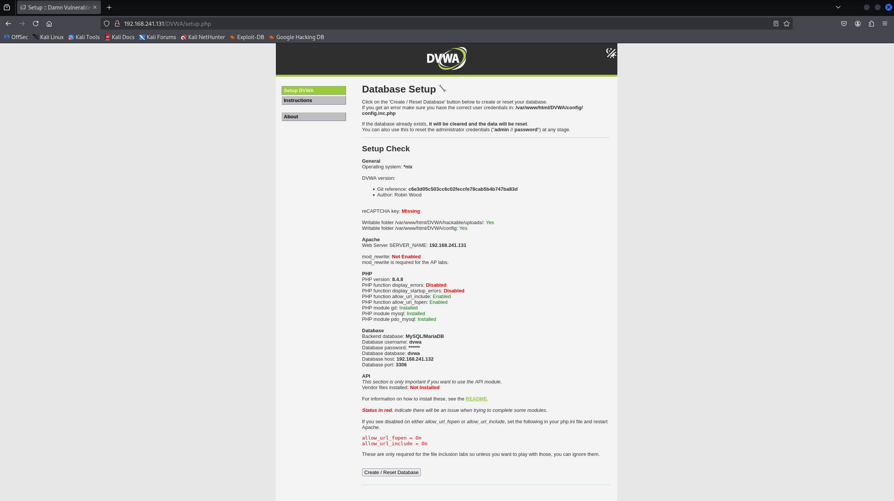
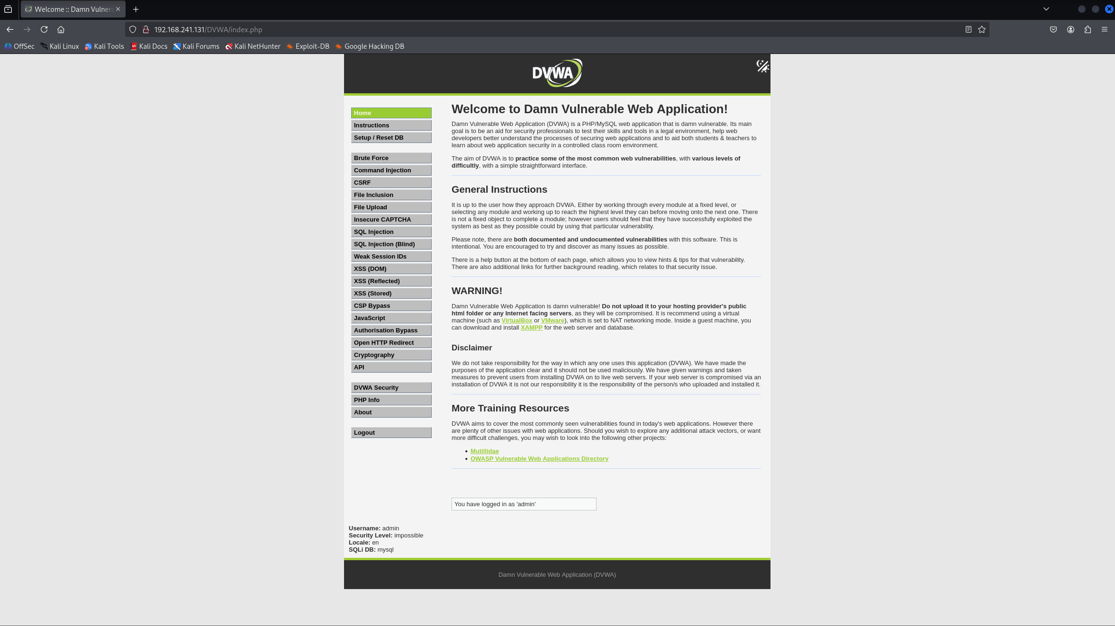

Step 20: Configure Client DNS Settings
Commands (on a client, e.g., host machine):
Explanation:
sudo nano /etc/resolv.conf: Configures the client to use VM1’s DNS server.
nameserver 192.168.241.131: Directs DNS queries to VM1.
search dvwa.local: Appends dvwa.local to unqualified names.
sudo systemctl restart networking: Applies network changes.
Function: Enables clients on the LAN to resolve dvwa.local using VM1’s DNS server.
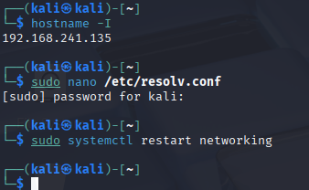
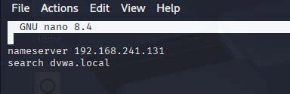

Step 21: Test DNS Resolution
Commands (on a client or VM1):
dig dvwa.local: Queries the A record (should return 192.168.241.131).
dig www.dvwa.local: Queries the CNAME record (resolves to dvwa.local).
dig -x 192.168.241.131: Performs a reverse lookup (returns dvwa.local).
nslookup dvwa.local: Confirms resolution.
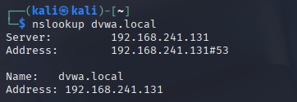

Step 22: Access DVWA via Domain Name
Commands:
Accessing http://dvwa.local/DVWA/setup.php: Resolves dvwa.local to 192.168.241.131 via VM1’s DNS server.
Clicking Create / Reset Database: Initializes the database on VM2.
Logging in: Confirms DVWA is accessible via the domain name.
Setting security to low: Configures DVWA for vulnerability testing.
Function: Verifies domain-based access to DVWA over the LAN, fulfilling the lab’s objective.
